MAY 2022 MARKETING PLAN

May is the month where everything is in full bloom! This month think bright, bold, colorful! Check out a few ideas below on how you can carry out this theme all month long.

getting started
- Review ideas and pick the ones you would like to do!
- Purchase the supplies needed for your events.
- Spread the word via graphics included for each event. You can find them in the galleries on each month’s page on the website.
- During each event *with permission* take photos and make sure to post to your social media to encourage future participation and remind attending residents of all the fun they had!
Keep in mind that the materials below are customizable to your property as far as time, date, and location. Simply reach out to the marketing department and specify which piece of collateral you want adjusted and send us your changes.

lovely Lemon rent breakfast

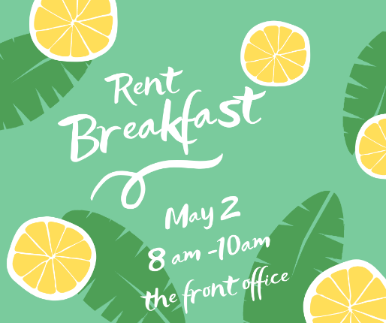
May 1st is National Lemonade Day. We thought it might be nice to use this as a jumping off idea for the month’s rent breakfast. Maybe offer a lemon forward breakfast option like lemon blueberry muffins or lemon poppyseed muffins. There are many options for lemon-based breads that are great for breakfast. You could offer fresh fruit as well. Offer lemonade to drink.
- Invite your residents via flyer, social media, textbox with the graphics included.
- On the day of your event, send out a reminder via textbox and social media.

Celebrating mom
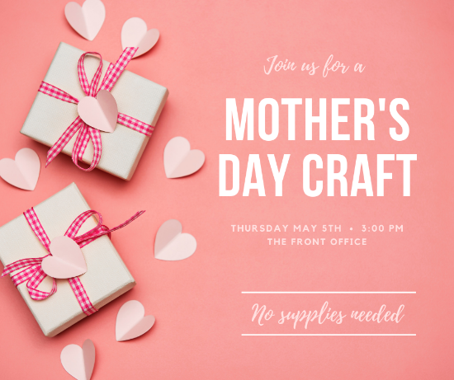
Spa Day Basket Raffle – Have residents enter to win throughout the week. Draw a winner and make your announcement via Facebook Page/textbox/email or however you get info to your residents the best.

Basket Ideas:
- Bath salts, scrubs, bath bombs, bath bubbles
- Slipper socks or socks
- Reading Material
- Scented Candle or Aromatherapy Items
- Facemasks, Cooling Eye Mask, Hand/Foot Scrub, Nail Polish
- Assorted Tea, Cookies, Candy
- A basket, tissue paper, and basket filler

Craft for Kids
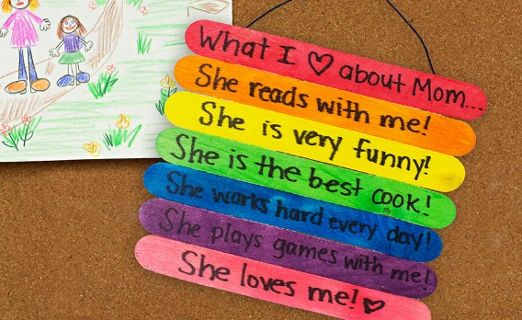
Organize a craft event where kids can come and make something special for their moms for Mother’s Day. (Flyer & Graphic available in Gallery)

A CRAFT IDEA - A rainbow reminder of what makes mom special.

What you need:
- Popsicle Sticks
- Markers
- Ribbon
- Glue
- A fine point marker for writing (You may have to help smaller residents)
- Paper Bags & Tissue Paper (item must be FULLY dry before packing up)
Instructions – Have children color their (8) popsicle sticks any way they like. Once completed, They should write “What I Love About Mom” on the very top stick. The following (6) should have a reason why mom is so great! The very last stick should be where they write their name. They should then flip the sticks over in order and glue a long ribbon up one side of the sticks, leave a loop at the top for hanging, and then glue all the way down the other side. This will hold all the sticks together.

Bonus: While they wait for their craft to dry, they can color a bag for their gift. If items are dry, they can put them in the bag and take home. If you feel they need to dry over-night, maybe they can pick them up the following day.

Mom’s Night Out
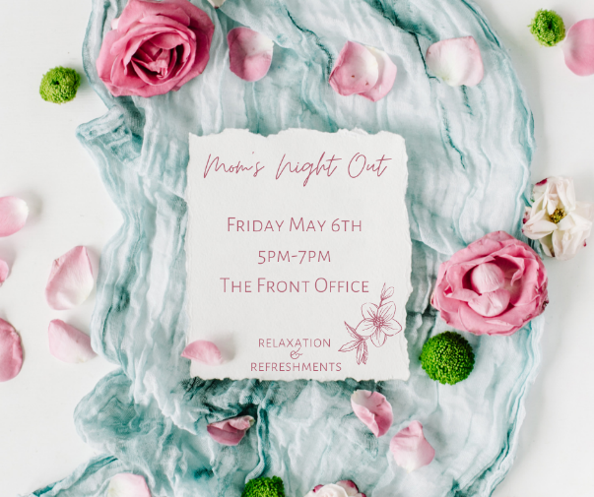
In today’s fast paced go-go-go world, it is not often Mom’s have time to just sit and take a moment to themselves. Host a night all about Mom’s ahead of Mother’s Day weekend.

Ideas:
Offer light snacks and beverages. Depending on your community’s preference (and upon checking with your regional) you could have wine/champagne, or you could have sparkling juices and maybe bubbling flavored waters. Either way, you could serve them in clear plastic flutes to add a fancy factor. For food, maybe crackers, cheese, veggie tray/fruit tray, cookies, muffins, etc. Anything to nibble on would be appreciated.
Play light fun music and have a set up that allows for chatting over snacks/drinks but also allows space for the mom that maybe just wants to sit, relax, and zone out. I would maybe have magazines around for perusing. You could even have nail polish sitting out in case anyone wants to do some self-care.
If your budget allows – maybe host a raffle. Ideas: Gift card to local restaurant or take out place to give mom a cooking break, a pedicure or manicure gift card, a small basket of chocolates and a bottle of wine, a small basket of relaxation items like facemasks, bath bombs, Epsom salt, hand lotion, nail polish, etc.

pizza party day event
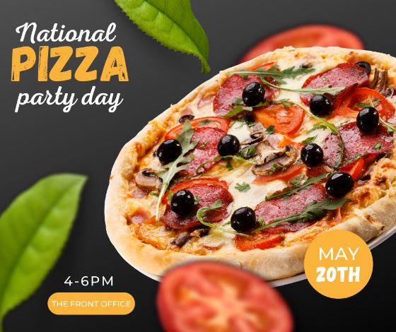
This one is simple. To Celebrate National Pizza Party Day -do just that. Host a pizza party! Take rsvp’s a few days in advance if you like.
Other items to get: paper plates, napkins, plastic cups, waters, sodas

THE DAY OF THE EVENT:
- Send out a reminder, set up your event, and enjoy!

Scavenger Hunt Day

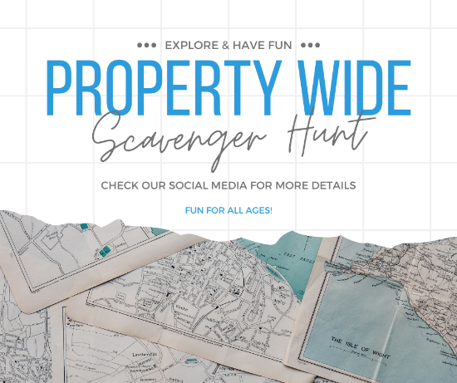
Host a Scavenger Hunt-Hide laminated clues around the community to be found! (You can easily laminate with packing tape and cut around the excess on the low budget end!) Decide how you will organize – Will it be teams? Will it be individuals? If Individuals, will the first 3 to find the answer win or just the one? Etc. Will you do it by first – or will everyone that submits the right answer get entered in a drawing? Decide what works best for your property and make sure your residents know how to play the game.

BEFORE THE EVENT:
- Send out flyer/social square/text box well in advance so your residents can plan on participating.
- Purchase your prizes.

THE DAY OF THE EVENT:
- Post the social media square announcing today is the day!
- Hide your clues and keep an eye on your social media page.
- Post photos on social media (with resident’s permission) to show others the fun event happening and encourage future attendance.

Summer Pool Party/Picnic Party
Summertime is fast approaching and a fun pool/or picnic party is just the thing to celebrate.
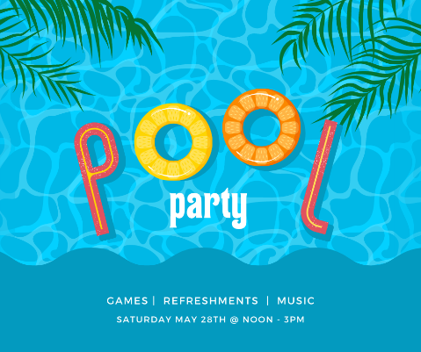
Pool – Make sure to get a few fun floats and games for the pool.
Five Below and Target both have floats for $5.
Inflatable Cornhole for the Pool: https://www.target.com/p/inflatable-cornhole-pool-game-sun-squad-8482/-/A-83280168?ref=tgt_adv_XS000000&AFID=google_pla_df&fndsrc=tgtao&DFA=71700000012577562&CPNG=PLA_Sports_Priority%2BShopping%7CSports_Ecomm_Hardlines&adgroup=Sports_Priority+TCINs&LID=700000001170770pgs&LNM=PRODUCT_GROUP&network=g&device=c&location=1015163&targetid=aud-1458285714903:pla-82703787769&ds_rl=1246978&ds_rl=1248099&gclid=CjwKCAjw6dmSBhBkEiwA_W-EoItEsOLtSCoW1ENlzKAGe9xMP7QKFOse2-uV90O4aZWtfni-duJTVhoC3cMQAvD_BwE&gclsrc=aw.ds
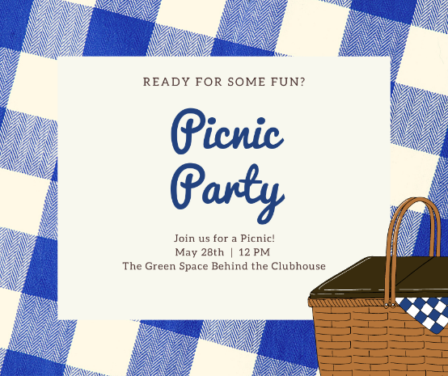
Picnic – You could always jazz up your picnic by getting a sprinkler toy for the kiddos on site! They are fairly inexpensive and provide lots of fun.
Sprinkler: https://www.target.com/p/melissa-38-doug-sunny-patch-pretty-petals-flower-sprinkler-toy-with-hose-attachment/-/A-50907724?ref=tgt_adv_XS000000&AFID=google_pla_df&fndsrc=tgtao&DFA=71700000012544494&CPNG=PLA_Toys%2BShopping%7CToys_Ecomm_Hardlines&adgroup=SC_Toys&LID=700000001170770pgs&LNM=PRODUCT_GROUP&network=g&device=c&location=1015163&targetid=aud-1601604867532:pla-322495969800&ds_rl=1246978&ds_rl=1248099&gclid=CjwKCAjw6dmSBhBkEiwA_W-EoLds7HyEznRey3rWQTdDDc_OLF9bEmryjaZ1Mz6LahZxU4Hz5HWn8xoC0BsQAvD_BwE&gclsrc=aw.ds
Have (appropriate) music playing, refreshments out like chips, fruits, popsicles, drinks, water*. Bonus – Provide a bottle of sunscreen in case anyone forgot theirs!

BEFORE THE EVENT:
- Send out Flyer/Social Square/ Text Box information
- Get refreshments and supplies.

THE DAY OF THE EVENT(s):
- Set Up, Send Reminder, Relax and Have Fun!

outreach
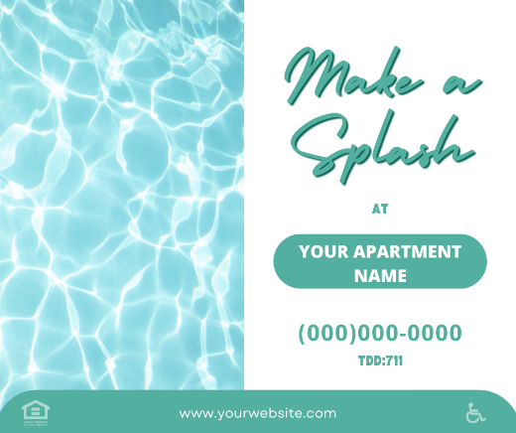
You will find outreach flyers in our gallery this month. If you are passing them out to local businesses and including a cardstock printout (find in gallery) -add a flavor packet for water attached to our “make a splash” flyer. We suggest If you are visiting a larger office with a breakroom, a box of lemon/coconut/sugar cookies would be a great addition to the flyer.
It’s getting nice out and people are finding more reasons to be outside or prepare their outdoor areas!
Get Involved with your Local Farmer’s Markets – Are there any events you can volunteer at or contribute too? Can you leave waters with your logo on them?
Plant Shops/Nurseries/Pool Stores/etc. – Think about places offering items that help people prepare for summer!

National Holidays for Calendar
May 1st- National Lemonade Day
May 2nd – International Harry Potter Day
May 3rd – National Teacher Day
May 4th- Star Wars Day
May 5th – Cinco de Mayo
May 6th – National Nurses Day
May 8th – Mother’s Day
May 9th – National Moscato Day
May 10th – National Mental Health Awareness Week
May 11th – National Technology Day
May 13th – National Apple Pie Day
May 15th – National Chocolate Chip Day
May 16th – Drawing Day/National Mimosa Day/ National Do Something Good for Your Neighbor Day
May 18th – National Visit Your Relatives Day
May 20th – National Pizza Party Day/ National Pick Strawberries Day
May 21st – National Learn to Swim Day/ National Armed Forces Day/ Eat More Fruits & Veggies Day
May 22nd – National Vanilla Pudding Day
May 23rd – National Safe Sun Week
May 24th – National Scavenger Hunt Day
May 26th – National Paper Airplane Day
May 27th – National Heat Awareness Day
May 28th – National Hamburger Day
May 29th – Indianapolis 500
May 30th – Memorial Day

