FEBRUARY 2023 EVENTS

February is a month that is synonymous with love and friendships. Check out a few ideas below on how you can carry out this theme all month long.

getting started
- Review ideas and pick the ones you would like to do!
- Purchase the supplies needed for your events.
- Spread the word via graphics included for each event. You can find them in the galleries on each month’s page on the website.
- During each event *with permission* take photos and make sure to post to your social media to encourage future participation and remind attending residents of all the fun they had!
Keep in mind that the materials below are customizable to your property as far as time, date, and location. Simply reach out to the marketing department and specify which piece of collateral you want adjusted and send us your changes.

february rent breakfast

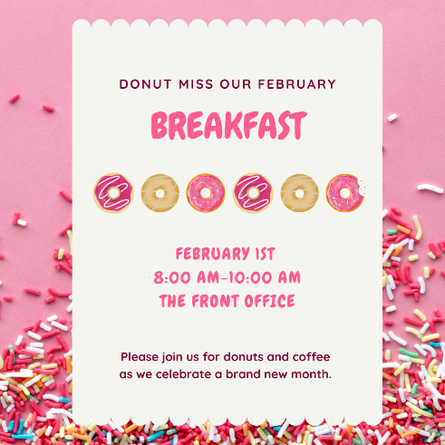
Invite your residents to the office for a rent breakfast full of love. Make sure to have a spread of donuts that incorporate pinks/reds/whites to go with your theme. Display the printout in our Gallery letting your residents know that you love having them in your community. You could maybe sweeten things up with a few little bowls of candy with scoops and takeaway bags to go (cellophane bags, bowls, and scoops will be cheapest at your local Walmart). Have juices that are pink like pink lemonade or make a punch with strawberries. The sky is the limit.
- Invite your residents via flyer, social media, textbox with the graphics included.
- On the day of your event, send out a reminder via textbox and social media.

Win a date night on us event
Post/hand out your flyers for the event on Tuesday February 1st to give residents plenty of time to come in and submit their guesses.

BEFORE THE EVENT:
- Find/purchase a large glass jar and fill with treats of your choice. (count as you fill) Put somewhere in the office where it is very visible. Make sure to post the flyer next to the jar so people coming in know what to do!
- Have a drop box where residents can drop a piece of paper with their name/unit/guess on it. Make sure you can’t see through the drop box so all guesses are anonymous.
- Purchase a gift card to a local restaurant.

THE DAY OF THE EVENT:
- Open up your drop box and see who was closest to the number of candies in the jar. (It will be up to you if you are looking for the closest guess, or closest without going over – just make sure the rules are clear in advance).
- Announce via social media your winner and send a personal note to the winner letting them know to come get their prize!

black history month trivia contest
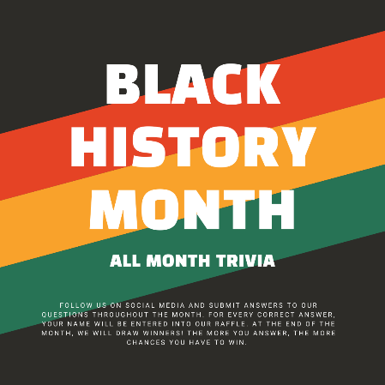
Throw an online trivia contest for your community. Let your resident know you will be hosting a contest via social media graphic. On your social media, post questions throughout the month. For every right answer your residents post, enter their name in a drawing. At the end of the month, draw your winners! The more they participate, the more chances they have to win.

BEFORE THE EVENT:
- Find trivia questions here

- Find Graphic to post alongside your questions in our marketing gallery for February.

- Purchase prizes – how many and for how much will depend on your community budget.

valentine candy grams event
Let friendship flourish in your community as residents have the opportunity to sign up to send a candy-gram to others in the community.

BEFORE THE EVENT:
- Send out flyer/social square/text box well in advance so your residents can plan as well as sign-up.
- Purchase your supplies.
- Take orders in advance.

THE DAY OF THE EVENT:
- Post the social media square announcing today is the day!
- Have team members pass out candy-grams throughout the community.
- Post photos on social media (with resident’s permission) to show others fun events happening and encourage future attendance.

WHAT YOU’LL NEED
- Cellophane bags from Walmart
- Candy Hearts or skip the bags and hand out boxes of candy hearts or choose a candy of your choice.
- Tie a tag to them like these or stickers like these.

Sunday Tailgate & watch party
Let’s celebrate LOVE of the game! Sunday is the biggest football game day of the year. This event covers your sports fans, the residents who just want to see the commercials, half-time show viewers, and anyone that enjoys food with good company. It really works for everyone.
IMPORTANT NOTE:
* Be careful using the wording "Super Bowl" or "The Big Game" in reference to this event. * See Below:
"Without express written permission from the NFL and/or the teams involved, you may not use the following, or related protected words or logos, in marketing or promotions, whether on-air, in print, online, or otherwise: “Super Bowl” “Super Sunday” The Super Bowl logo"

Something to consider; The game will run late into the evening Sunday. You could always mix and match with a tailgate lunch beforehand as a stand-alone event or coupled with a virtual party to watch the game. If you do a tailgate party, make sure to have something like cornhole to play for entertainment.

BEFORE THE EVENT:
- Send out Flyer/Social Square/ Text Box information
- Purchase Supplies
- If it’s an in-person watch party make sure you can watch the game on your tv/projector and make sure you know which channel the game is on. Going virtual? Practice your virtual broadcast before game day. Ensure you’ll have access to the game and can host a virtual viewing session.

THE DAY BEFORE OR THE DAY OF THE EVENT:
- Send out a reminder

WHAT YOU’LL NEED
- Football Decor
- Cups/Plates/Cutlery/ Tablecloths -supplement with solid color options from your local Walmart.
- Food
  - Hot dogs, burgers, chips, dips, pretzels, soda, water, etc.
  - Have a bigger budget? Consider footlong subs & pizzas.

Muffins To-Go
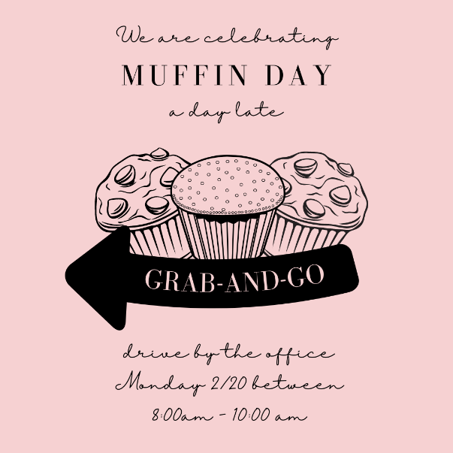
Show your residents some love by taking breakfast prep off of their to-do list. National Muffin day falls on Monday 2/20. Ask residents to drive by the office and grab one while supplies lasts!

BEFORE THE EVENT:
- Visit your local grocery store and grab a few packs of bakery muffins.
- Grab cellophane bags at Walmart to individually wrap the muffins in.
- Post social graphics and hand out flyers in advance of your event so residents can plan on it.

THE DAY OF THE EVENT:
- Post the social media square to remind your residents.

for the love of (music/art/etc.) workshops
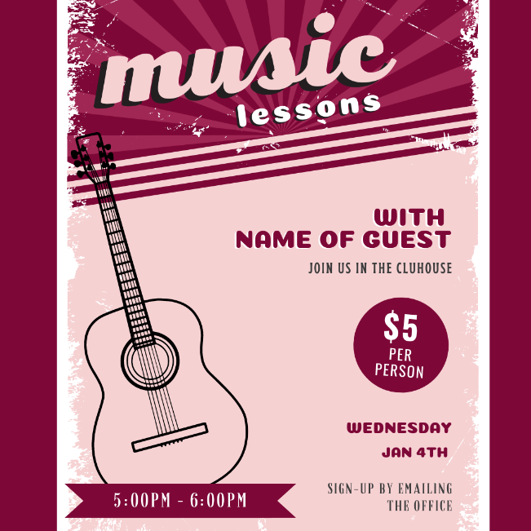
Help your residents discover the love of a new hobby! Take an hour each week to wind down with a creative escape. Do you know any artists in your area that you could book for a class each Wednesday? If it is something that sticks, it could be a new partnership that adds to your community. Ideas: Music Lessons, Painting Lessons, Photography Lessons, Floral Lessons, Pottery Lesson, Calligraphy Lessons, etc.

BEFORE THE EVENT:
- Have a sign-up method in place so you know how many people to expect.
- Send out information on what supplies residents will need to bring vs. what will be provided for them.
- Post social graphics and hand out flyers in advance of your event so residents can plan on it.

THE DAY OF THE EVENT:
- Post the social media square to remind your residents.

outreach

Carnations are inexpensive and would be a sweet option to hand out with flyers. You could also hand out candy hearts in the spirit of the season. A 10 pack is $3 here.

- Flowers would also be a great gift to accompany resident renewal letters this month.

CALENDAR DAYS
February 1st - Rent Breakfast - Host a Rent Breakfast for your residents today. Theme it with pink's and reds and offer items that fit your theme. Maybe you could have croissants with fresh fruit, and pink grapefruit juice to match your table settings.
February 2nd - Groundhogs Day - This event would be a great opportunity to take a social media poll. Maybe offer a small prize to a lucky resident who guessed correctly in the poll. Make sure to track who said what before Punxsutawney Phil makes his prediction!
February 3rd - National Wear Red Day- Ask everyone on-site to wear red today in support of heart health!
February 4th – National Thank a Mailman Day
February 5th – Western Monarch Day – The Monarch Butterfly recently made the endangered list. A way we can all help preserve this beautiful butterfly is to plan Milkweed – it’s feeding source. The groups below will send you free seeds for planting based on your location. You can also purchase larger quantities of seeds. With a bag or two of dirt, a few containers (you could even use old recycled items) and seeds, you could host an event where residents come to plant milkweed, learn a little about monarchs, and take a plant or two home. Once the milkweed begins to grow on balconies/patios – you might just get a flock of butterflies around the community! It’s a win/win.
https://www.livemonarch.com/
https://monarchwatch.org/
February 7th – National Send a Card to a Friend Day – have cards in the office for sending out today. You can get affordable packs of cards in the dollar aisle at Target or at Dollar Tree.
February 9th – National Pizza Night – Partner with a local pizza place and see if they can offer a coupon for your residents or have a neighborhood night where delivery is discounted, etc. You could also order pizza for dinner in the office.
February 10th- National Flannel Day- Channel the Flannel today in the office.
February 11th – Peppermint Patty Day – York Peppermint Patties for everyone today!
February 12th- Super Bowl Sunday - Check out our February Marketing Plan to get ideas on how to celebrate!
February 14th - Valentine’s Day - Check out our February Marketing Plan to get ideas on how to celebrate!
February 17th – Random Acts of Kindness Day. See list of 50 Random Acts of Kindness ideas here.
February 18th – National Girl Scout Cookie Weekend – Post info on where residents can buy cookies locally. Are there any in your community? Maybe send out info in advance asking – It today’s world you can plug in their troop number and name online and order off the website. You could also offer up space in front of your office if you get a lot of foot traffic.
February 20th - National Muffin Day - Check out our February Marketing Plan for a Muffin Grab-N-Go Event
February 20th - President’s Day - It's a good day to post a favorite presidential quote to inspire the community.
February 21st - Mardi Gras – For a low-key event, Give out Moon pies and Beads in the office today. Purchase them here.
February 24th - National Chili Day - Host a best chili contest and invite makers as well as taste testers! Vote on best chili and announce your community's reigning champ via social media. If your plate is full already - you could always ask residents via social to tag a local restaurant that serves the best chili or partner with a local restaurant to offer your residents a discount today only on chili.
February 25th – Check your Social Media/ Internet Listings/Website to make sure your information is up to date.
February 27th - National Strawberry Day - Are there any local strawberry farms nearby opening for a u-pick season? If so, today is a great day to let your residents know.

