MARCH 2023 EVENTS

March is a month that is synonymous with all things Green. Check out a few ideas below on how you can carry out this theme all month long.

getting started
- Review ideas and pick the ones you would like to do!
- Purchase the supplies needed for your events.
- Spread the word via graphics included for each event. You can find them in the galleries on each month’s page on the website.
- During each event *with permission* take photos and make sure to post to your social media to encourage future participation and remind attending residents of all the fun they had!
Keep in mind that the materials below are customizable to your property as far as time, date, and location. Simply reach out to the marketing department and specify which piece of collateral you want adjusted and send us your changes.

BAGEL rent breakfast

Invite your residents to the office for a rent breakfast to kick off the month. Most grocery stores and bakeries will have a variety of bagels to choose from. Don’t forget to pick up cream cheese and a jelly/jam spread for those that can’t have dairy. You will need small plates/napkins/and plastic knives for serving. Depending on if they are toasted, you may need to have a toaster available. Don’t forget about small drink cups and juice to go with it.
- Invite your residents via flyer, social media, textbox with the graphics included.
- On the day of your event, send out a reminder via textbox and social media.

spa night event
Post/hand out your flyers for the event early to give residents plenty of time to let you know if they will come so you can plan accordingly. Decide if you want an event where residents come to the office and stay or if you want to do the grab and go version.

BEFORE THE EVENT:
- Spa Night/Takeaway ideas: Makeup remover individual packets, face masks, under eye treatments, (individual)nail files/buffers, nail polish, polish remover, lip scrub, hand scrub, hand cream, face cream * plastic spoons so creams/scrubs can be shared without hands directly in it.
- Takeaway only ideas: Bath Bomb or decorative bag of scented Epsom salt, lip balm, cellophane bags with ribbon.
- If In house: Make sure to have a nice scent in the air, soft music, maybe a few magazines or books to look through, and a fun water with cucumber or oranges in it.

THE DAY OF THE EVENT:
- Send out a reminder and get ready to get your spa on!

herb garden diy event
Beautify the community and promote growth by hosting an Herb Garden DIY Event! Invite residents to an outdoor space on site to plant herbs they can take home and eventually use in their kitchen. Send out flyer and social media in advance so residents can plan.

what you will need:
- Buy seeds here
- Buy planters here
- Soil and plastic spoons will most likely be cheapest at your local Walmart. Pick up a few plastic tablecloths for easy cleanup.
- If you want to add extra flair, print out suggestions for the herbs you are offering. -example: Basil is a great way to dress up your pasta dishes or add to pizza. Lavender can be used to make your own candles. Etc.

THE DAY OF THE EVENT:
- Send out a reminder, set up your supplies, and enjoy!

build your own bouquet event
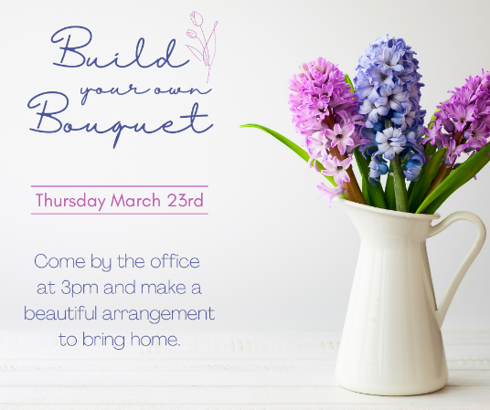
A fresh bouquet of flowers is an instant mood lifter and just seems to brighten a room. Partner with a local florist or call up your local grocery store with a floral department and arrange to pick up flowers. Most grocery florals also offer 3 for 12 assorted bouquets. Make sure you pick up filler (leaves, baby’s breath, etc.) as well as just flowers. Your local dollar tree or Walmart will have vases you can pick up. You can also reuse/recycle with glassware contained grocery items. Some pasta jars, salsa jars, etc. have a pretty shape or design and can be cleaned and used. If you are looking for extras, you could also have ribbon and a handful of tags in case a resident intends to give them away or write a cute message.

BEFORE THE EVENT:
- Send out flyer/social square/text box well in advance so your residents can plan to sign-up.
- Purchase your supplies.

THE DAY OF THE EVENT:
- Post the social media square announcing today is the day!
- Set up your building area and supplies. Cheap tablecloths make for easy cleanup.
- Post photos on social media (with resident’s permission) to show others fun events happening and encourage future attendance.

WHAT YOU’LL NEED
- Dollar Store Vases
- Flowers & Filler
- Scissors for cutting ends

find the leprechaun event
A scavenger hunt always makes for a great time! Get your residents out and about searching the property – which in turn also gets them visiting parts of the community maybe they forgot about or don’t utilize as much but could in the future.

BEFORE THE EVENT:
- Send out Flyer/Social Square/ Text Box information
- Print out a paper leprechaun ( or multiple if you choose – if multiple, reach out to us to edit the marketing materials). Laminate your leprechaun in case of rain or sprinklers. You can get this done at Office depot for around $2 or if you have a roll of packing tape, you can diy it.
- Hide your leprechaun(s)!
- Get a prize for your winner(s).

THE DAY OF THE EVENT:
- Send out a reminder
- To make the most of the event, we suggest doing a drawing of everyone who submits so your event lasts all day and allows people the opportunity to play at a time that works for them as opposed to whoever finds it first.
- Make sure to announce a winner before close of business or the following day and have your winner(s) come get their prize.

lunch To-Go
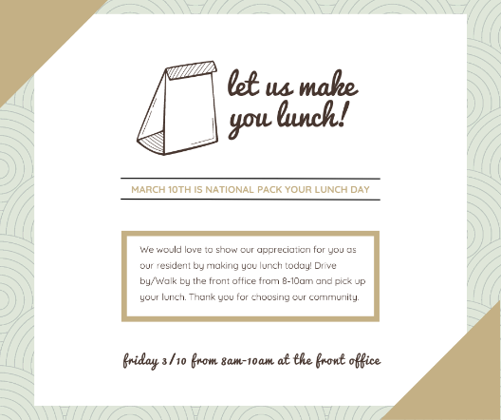
Show your residents some love by taking lunch prep off their to-do list. Ask them to drive by the office and grab one while supplies lasts!

BEFORE THE EVENT:
- Visit your local grocery store and grab items to make pb&j, uncrustables, or a deli meat and cheese option. Make sure to pick up sandwich bags to put them in. Include a piece of fruit like bananas, cuties, or apples. Pick up variety individual bags of chips. Include a pack of cookies or rice krispy treat. If budget allows, throw in a bottled water or capri sun. Make sure to purchase paper bags for lunches to be put in.
- Post social graphics and hand out flyers in advance of your event so residents can plan on it.

THE DAY OF THE EVENT:
- Post the social media square to remind your residents.

outreach
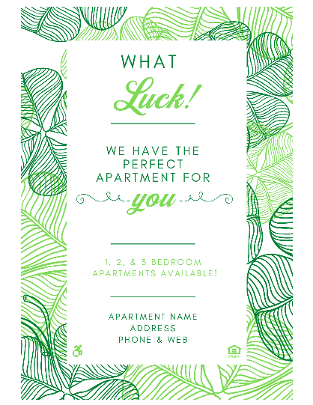
You will find outreach flyers in our gallery this month. They are Luck themed. If you are passing them out to local businesses and including candy, we suggest cellophane bags filled with gold candies (rolos, werthers, gold Hershey kisses, gold chocolate coins, etc.) tied with a gold or green ribbon. If you are visiting a larger office with a breakroom, a box of Ferrero Rocher candies or a gold box of assorted chocolates would be a great addition to the flyer.

MARCH CALENDAR DAYS
01 – Rent Breakfast
02 – Read Across America Week: This week is ideal to do a book reading for kiddos in the office or to host a book swap! You could also tag your local library or post how easy it is to get your free library card (and in many cities they come with benefits like access to museums for free!)
03 – World Wildlife Day: Is your community doing anything for wildlife in the area? A butterfly Garden, A bird feeder making event, highlighting local wildlife near the community? https://wildlifeday.org/en/getting-involved
04 – National Snack Day: Have a fun snack in the office today!
05 - Library Card “How To” Post: Visit your local library’s website and see their steps for getting a library card. Post them on your social. Nowadays a local library card not only gets you free book rental but oftentimes it offers access to digital books and free entrance to local museums and other educational venues.
08 – Holi: Holi is known as the festival of colors. It is one of the most important festivals in India. Holi is celebrated each year with zeal and enthusiasm in the month of March by followers of the Hindu religion.
12 – Girl Scout Day: Support your local girl scouts. Can you schedule an encouraging post reminding residents that it’s a great time to buy them this week? Maybe post a survey for the community favorite cookie? Host a cookie event!
14 – Pi Day: Did someone say Pi? It is a great day to invite residents to the office for a slice of pie. Check out our flyer/social gallery for imagery.
15 –Down Syndrome Awareness Week: Visit this link for ideas on how your community can participate. https://www.worlddownsyndromeday.org/
17 – St. Patrick’s Day: See the Marketing Plan for event ideas. As far as outreach goes, are there any events going on this week where your team could set up a booth, hand out property swag, leave flyers for people to see?
18 – Global Recycling Day: Is there any recycling centers nearby to recommend? Any ideas for Reuse event (glass jars, egg cartons, plastic bottles)?
19 – Red Nose Day: Bust out your red noses today! Post a fun picture of your staff on Social and challenge your residents to do the same and tag your community. If you want to go all out, set up a photo booth in the office!
20 – Spring Equinox: Hooray for Spring!
21 – Free Cone Day: Are there any local ice cream shops participating?
23 – Ramadan: It is observed by Muslims worldwide as a month of fasting, prayer, spiritual reflection, and unity.
25 – Earth Hour: Earth Hour was created by the World Wide Fund for Nature (W.W.F.) and is held annually, encouraging individuals, communities, and businesses to turn off non-essential electric lights, for one hour, from 8:30 p.m. to 9:30 p.m, as a symbol of commitment to the planet.
26 – National Cleaning Week: Challenge your residents to a specific cleaning challenge daily. Think kitchen junk drawer, outdoor closet, clean out clothes closet, under the sink organization challenge, etc.
27 – World Autism Acceptance Week: Are there any resources in the community for our friends with Autism?
29 – World Piano Day: Celebrate by having piano music in the background today. Many newer albums these days have a purely piano version. Who knows, it may become a relaxing new addition to your day.
31 – National Crayon Day: Host a coloring contest!

