JUNE 2022 MARKETING PLAN

June is the month where Summer is finally here! This month think bright, fun, colorful! Check out a few ideas below on how you can carry out this theme all month long.

getting started
- Review ideas and pick the ones you would like to do!
- Purchase the supplies needed for your events.
- Spread the word via graphics included for each event. You can find them in the galleries on each month’s page on the website.
- During each event *with permission* take photos and make sure to post to your social media to encourage future participation and remind attending residents of all the fun they had!
Keep in mind that the materials below are customizable to your property as far as time, date, and location. Simply reach out to the marketing department and specify which piece of collateral you want adjusted and send us your changes.

Doughnut rent breakfast

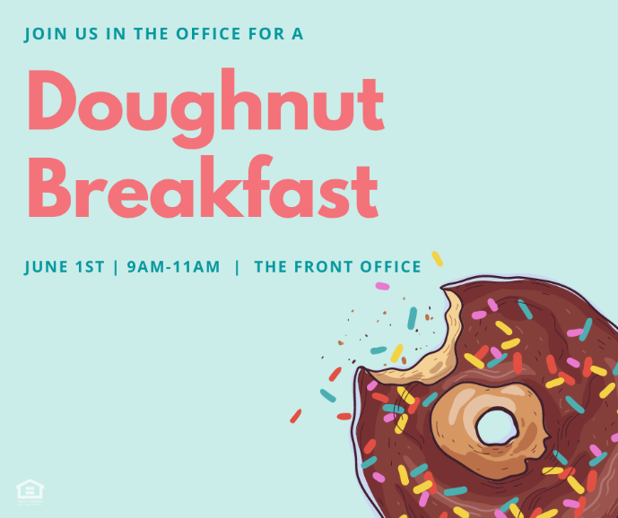
It’s a great month to take it easy and do something simple that is a fan favorite. Visit your local doughnut shop and get a few dozen doughnuts as well as some milk/milk alternatives for your rent breakfast.
- Invite your residents via flyer, social media, textbox with the graphics included.
- On the day of your event, send out a reminder via textbox and social media.

Celebrating Dad
Host a Raffle – Have residents enter to win throughout the week. Draw a winner and make your announcement via Facebook Page/textbox/email or however you get info to your residents the best.

Basket Ideas:
- Coffee/Coffee Mug/Tumbler
- Assorted Nuts/Chocolates/Cookies/Candies
- Amazon Gift Card/ Tech Items like chargers/headphones/etc.
- Socks /Notepad/Scented Candle
- BBQ Items/Seasonings/Hot Sauces
- A basket, tissue paper, and basket filler

Craft for Kids
Organize a craft event where kids can come and make something special for their dads for Father’s Day. (Flyer & Graphic available in Gallery)

A CRAFT IDEA – Father’s Day Toolbox Craft

What you need:
- Colored Printer Paper/White Printer Paper
- Crayons/Colored Pencils
- Glue
- A pen or pencil
- Paper Bags & Tissue Paper (item must be FULLY dry before packing up)

Instructions – https://www.123homeschool4me.com/cute-toolbox-fathers-day-craft/
Bonus: While they wait for their craft to dry, they can color a bag for their gift. If items are dry, they can put them in the bag and take home. If you feel they need to dry over-night, maybe they can pick them up the following day.

World Bicycle day event
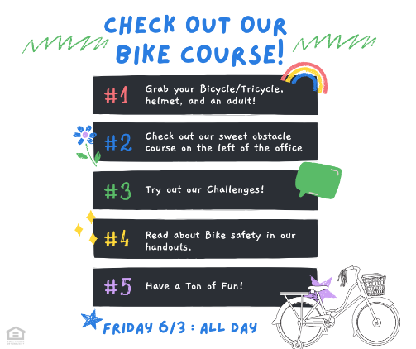
Find a safe place on-site to block off a chalk obstacle course & balance challenges for your residents. Have a flyer/handout with safety tips to take home. Also have a bucket of bottled waters out in ice.

THE DAY OF THE EVENT:
- Send out a reminder, set up your event, and enjoy!

Ice Cream Party Event

Host an Ice Cream Party! With the summer heat, cold treats are always a welcome surprise.

BEFORE THE EVENT:
- Send out flyer/social square/text box well in advance so your residents can plan on participating.
- Purchase your supplies: (Bowls, Spoons, Ice Cream, Toppings are endless but a few suggestions would be syrup, sprinkles, chocolate chips, or candy pieces toppings.)

THE DAY OF THE EVENT:
- Post the social media square announcing today is the day!
- Post photos on social media (with resident’s permission) to show others the fun event happening and encourage future attendance.

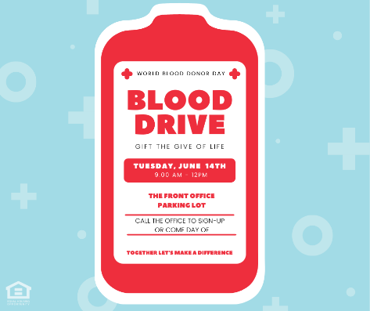
Host a Blood Drive
Reach out to the OneBlood: https://www.oneblood.org/?https://www.oneblood.org/donate-now/?utm_source=google&utm_medium=ppc&utm_content=system-wide-general&utm_term=r-all&utm_campaign=r11-greenville-june-july-incentive&utm_category=marketing-programs&location_id=1015163&gclid=Cj0KCQjwyMiTBhDKARIsAAJ-9VtBsQDbyfOZoDqiiP0XBiJnYjET-tUsqju4XMObw44aRvETWD41kCgaAqjdEALw_wcB
This organization makes it super easy. They help you designate a day/time and then they handle the rest essentially. They even provide signage for you. (We have also included it in case.) Think about a place on-site that would be convenient to park their large bus.

BEFORE THE EVENT:
- Send out Flyer/Social Square/ Text Box information
- Make a signup sheet and try and get appointments if possible.
- You could offer some sort of concession or raffle for those taking part and/or have cookies/juice for participants after they donate.

THE DAY OF THE EVENT(s):
- Set Up & Send Reminder

International yoga Day class
Reach out to your local Yoga Studio and see if anyone is interested in hosting a class at your property. You could use the gym or possibly an outdoor location. If it gains a lot of interest, maybe it’s something to think about continuing. It will most likely be very important to get attendees signed up ahead of time to make sure your instructor can handle the capacity (or to know if this simply just isnt an interest in your community).
Provide Water for participants.

THE DAY OF THE EVENT:
- Send out a reminder, set up your event, and enjoy!

outreach
You will find outreach flyers in our gallery this month. If you are passing them out to local businesses and including a cardstock printout (find in gallery) -add a flavor packet for water attached to our “make a splash” flyer. We suggest If you are visiting a larger office with a breakroom, a box of lemon/coconut/sugar cookies would be a great addition to the flyer.
It’s getting nice out and people are finding more reasons to be outside or prepare their outdoor areas!
Get Involved with your Local Farmer’s Markets – Are there any events you can volunteer at or contribute too? Can you leave waters with your logo on them?
Plant Shops/Nurseries/Pool Stores/etc. – Think about places offering items that help people are enjoying summer!
Visit local pools, parks, and outdoor activity hotspots for your community.

National Holidays for Calendar
1st- Dinosaur Day; Say Something Nice Day
2nd – National Rocky Road Day
3rd – World Bicycle Day; National Donut Day
4th- National Trails Day; National Hug Your Cat Day
5th – World Environment Day
6th – D-Day; National Gardening Exercise Day
7th – National Chocolate Ice Cream Day
8th – World Oceans Day
10th – National Iced Tea Day
11th – National Rose’ Day; National Making Life Beautiful Day
12th – National Peanut Butter Cookie Day
14th – Flag Day; World Blood Donor Day
17th – World Eat Your Veggies Day
18th – National Go Fishing Day
19th – Juneteenth; Father’s Day
20th – National Ice Cream Soda Day
21st – International Yoga Day
23rd – National Hydration Day
24th – Check Your Website/Social Media Reminder
26th – National Chocolate Pudding Day
27th – National PTSD Awareness Day
30th – Social Media Day

